Hoover Science Experiment Exhibit

Hoover Student Council invites students in grades 3-5 to individually submit science experiments to the Hoover Science Experiment Exhibit on Friday, June 9th. Classes in K-2 may submit a class project that they’ve completed together.

Guidelines for the science experiments are simple:
- Have fun, this isn’t a competition!
- Use the Scientific Method to submit an experiment, not a project.
- Each experiment should be displayed on a tri-fold board with each step of the scientific method displayed. (see back for example)
- The final exhibit should reflect the work done by students, not parents. It is ok to consult your parents, but not have them do the work for you.

When submitting your experiment and results the following items are prohibited on exhibition: (pictures are encouraged)
- All living organisms (e.g. plants animals, microbes), pathogenic microbial and fungi cultures, live or dead, including unknown species.
- Dried plant materials, soil samples, and insect collections
- Taxidermy specimens or parts and preserved vertebrate or invertebrate animals (including embryos) except for human or animals teeth, hair, nails, and animal bones, histological dry mount sections and wet mount tissue slides
- Chemicals, including water, controlled or hazardous substance or devices
- Food, either human or animal
- Syringes, pipettes, and similar dangerous or sharp devices
- Any flames, open or concealed
- Highly flammable display materials
- Tanks which have contained combustible gases, including butane and propane, unless they have been purged with carbon dioxide
- Operation of a Class III or IV laser or other devices requiring over 120 volts AC or DC
Science Experiment vs Science Project
Before jumping into the paper mache and baking soda to build a volcano that will spew out colored lava, remember that a science experiment tests a hypothesis to a question you had about something of interest to you. Find a topic that you find interesting and want to know more about, then conduct research to begin planning your experiment

Time Management and Planning
A good scientists knows that you need to time to think of your question, conduct research, plan and execute your experiment, gather your data and write your report. Sit down with a calendar and plan out how much time you’ll need for your particular experiment. Remember to plan ahead for prohibited material. Have a camera to take pictures of fungi or plants in their different stages if you can’t display them at the exhibit in June. This is where collaborating with your parents is very helpful!

The scientific method is a systematic way of learning about the world around us and answering questions.

- Purpose/Question
Ask a question.
- Research
Conduct background research. Write down your sources so you can cite your references.
- Hypothesis
Propose a hypothesis. This is an educated guess about what outcomes you expect from your question.
- Experiment
Design and perform an experiment to test your hypothesis (that will answer your original question). An experiment has an independent and dependent variable. You change or control the independent variable and record the effect it has on the dependent variable.
- Data/Analysis
Record observations and analyze what the data means. Often, you'll prepare a table or graph of the data.
- Conclusion
Conclude whether to accept or reject your hypothesis. Communicate your results.

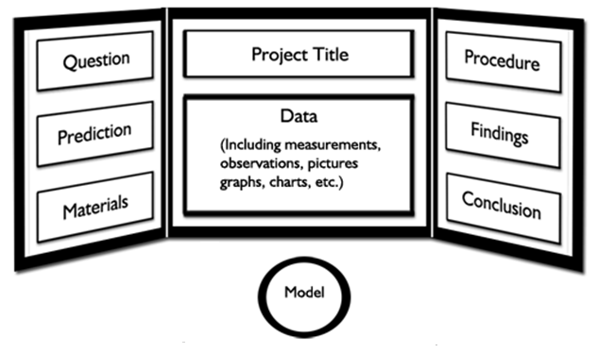
Science Experiment Display Board Set Up

**Unless your model contains materials included on the prohibited list, you may bring it to display at the exhibit to set up in front of the display board.**

